Day 4
- Count points for theme participation/drop off stuff
- Join big kids for first run through
- Snack at 10:00-10:15
- second run through with big kids
- Troll hair craft (headbands and colored tulle (cut)) may be lengthy and take more assistance from director and jr assistant.
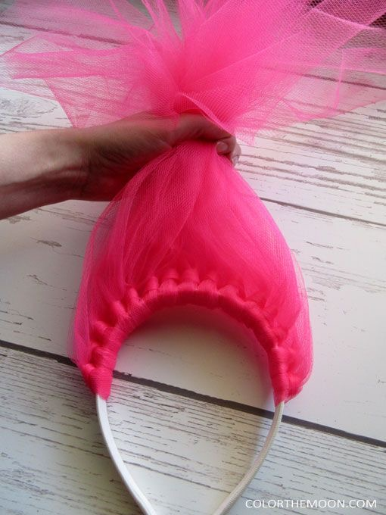
- and Mega Games 1:30-2:45
- If time during games clean up junior room and pack up bins
- 2:45 Dismissal

Day 5
- Morning announcements
- Full day with big camp, unless they need a snack break or if facility has an outdoor area for them
- Pizza lunch 12:00
- change into camp shirts
- Showcase at 3:00

